**OpenDJ – OpenAM**

**Installation and Configuration**

**Installation of java 8:**

**NOTE:** **Java should be Oracle SE - Java version - 1.8.0_221**

**Download Link:** <https://www.oracle.com/java/technologies/javase/javase8u211-later-archive-downloads.html>

Java SE Development Kit 8u221

**Downloadable filename: jdk-8u221-linux-x64.tar.gz**

Video Link: <https://www.youtube.com/watch?v=kiaWng4wR-k&list=PLWUs-qjlPXmlx6gkb4bWQrIQizspT2Z7p&index=2>

**Steps:**

1. **Add jdk binary to Download**
2. sudo mkdir /usr/lib/jvm
3. cd /usr/lib/jvm
4. sudo tar -xzvf ~/Downloads/jdk-8u221-linux-x64.tar.gz
5. Now we have to add environment variables: sudo gedit /etc/environment
6. **Add this line at the end in PATH variable that is already defined:**

:/usr/local/games:/usr/lib/jvm/jdk1.8.0_221/bin:/usr/lib/jvm/jdk1.8.0_221/jre/bin/snap/bin

So your PATH variable will become:

PATH="/usr/local/sbin:/usr/local/bin:/usr/sbin:/usr/bin:/sbin:/bin:/usr/games:/usr/local/games:/usr/local/games:/usr/lib/jvm/jdk1.8.0_221/bin:/usr/lib/jvm/jdk1.8.0_221/jre/bin/snap/bin"

1. Add these lines also in the file:

J2SDKDIR="/usr/lib/jvm/jdk1.8.0_221"

J2REDIR="/usr/lib/jvm/jdk1.8.0_221/jre"

JAVA_HOME="/usr/lib/jvm/jdk1.8.0_221"

1. Run following commands:

* sudo update-alternatives --install "/usr/bin/java" "java" "/usr/lib/jvm/jdk1.8.0_221/bin/java" 0
* sudo update-alternatives --install "/usr/bin/javac" "javac" "/usr/lib/jvm/jdk1.8.0_221/bin/javac" 0
* sudo update-alternatives --set java /usr/lib/jvm/jdk1.8.0_221/bin/java
* sudo update-alternatives --set javac /usr/lib/jvm/jdk1.8.0_221/bin/javac
* update-alternatives --list java
* update-alternatives --list javac

1. **Go to root and Reboot**: sudo reboot
2. Now check if java is installed or not: java -version
3. cd ~
4. sudo nano .bashrc
5. Add following lines at the end of the file:

export JAVA_HOME=/usr/lib/jvm/jdk1.8.0_221

export PATH=$PATH:$JAVA_HOME/bin

1. Save and exit
2. Source .bashrc

**Installation of OpenDJ (Version- 3.0):**

Video Link: <https://www.youtube.com/watch?v=iXpX9sMfJis&list=PLWUs-qjlPXmlx6gkb4bWQrIQizspT2Z7p&index=4>

1. Copy OpenDj zip file in Downloads
2. Unzip opendj
3. Sudo nano /etc/hosts
4. Enter following line in opened file:

127.0.0.0 opendj.test.com

(Note: You can give name as per your wish)

1. Now go in the unzipped folder: cd /Downloads/opendj
2. Open Setup by command: ./setup
3. A GUI will open. Follow steps as per screenshots below

(Also if GUI doesn’t open, Command line setup will begin. Enter details as per screenshots)

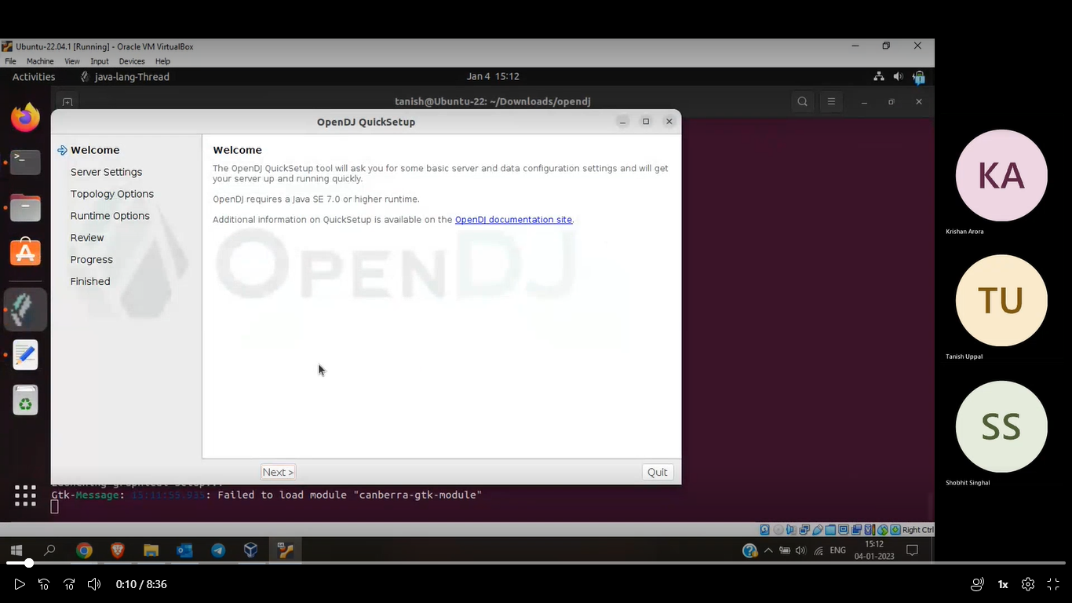

Note: Enter the hostname which you entered in hosts file and give password as per your choice

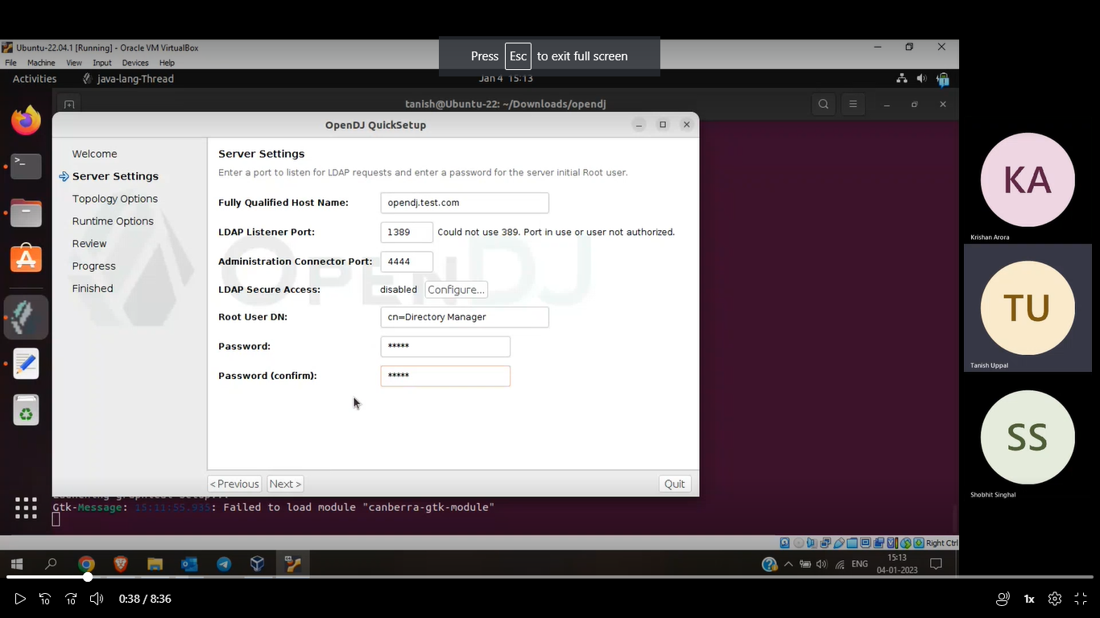

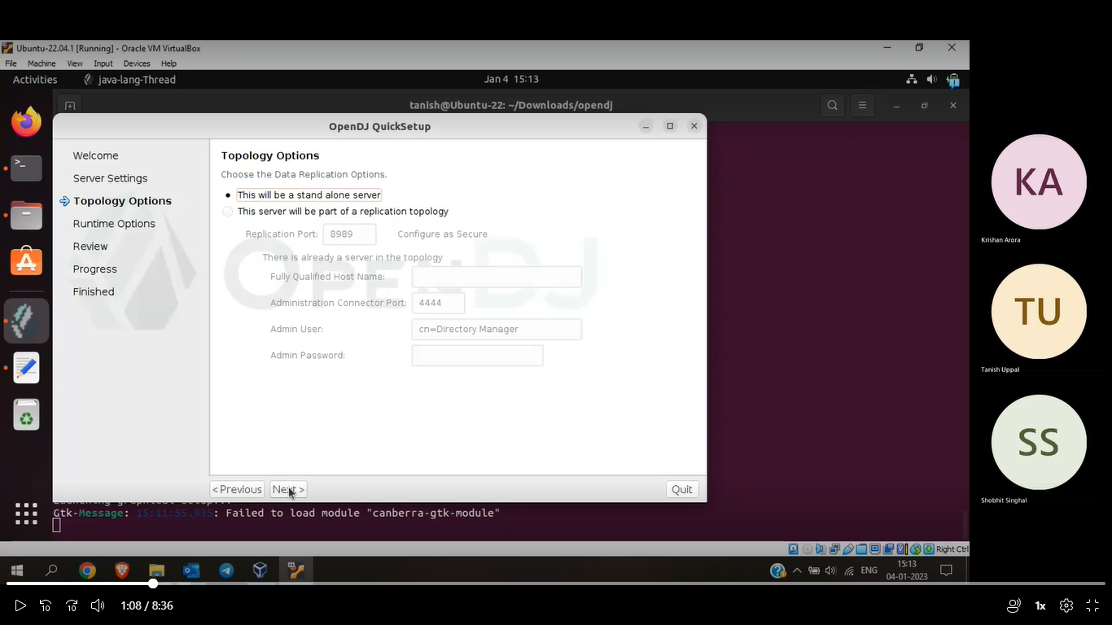

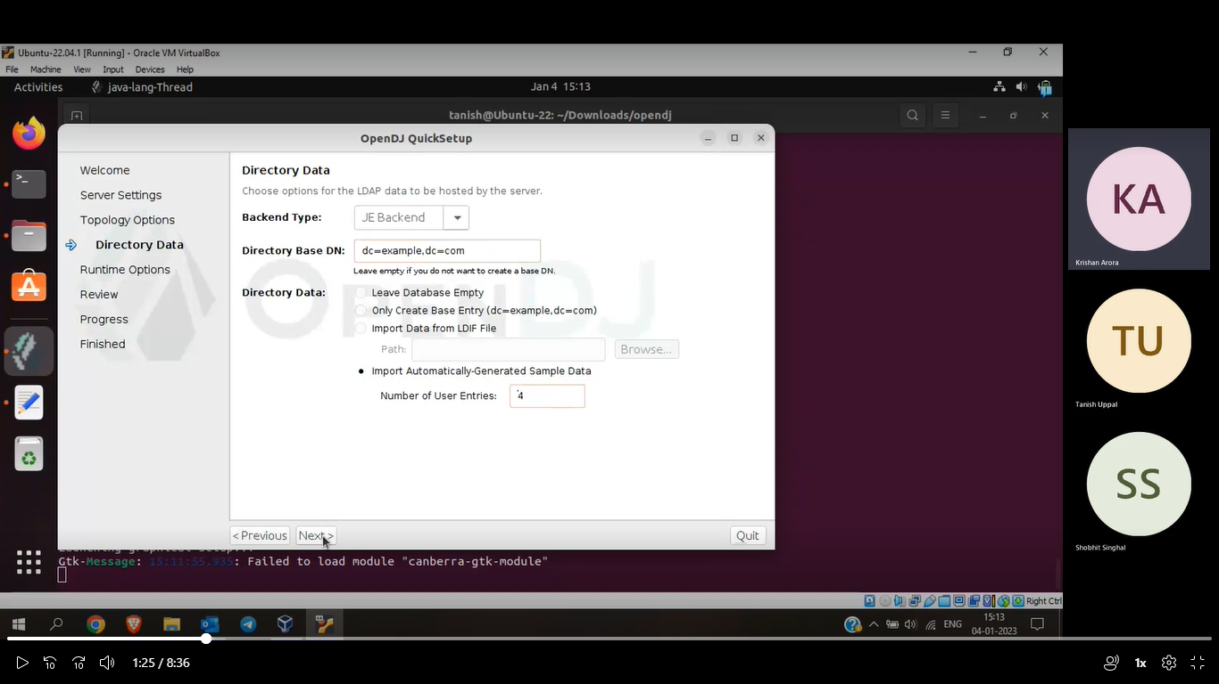

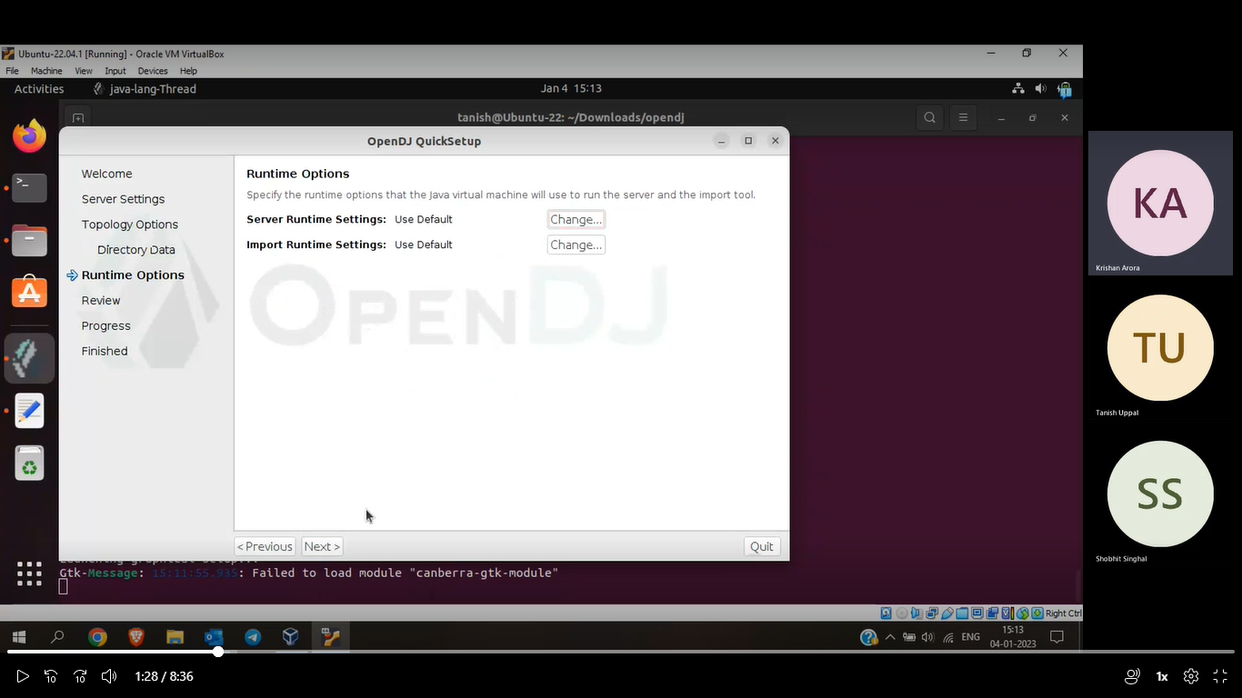

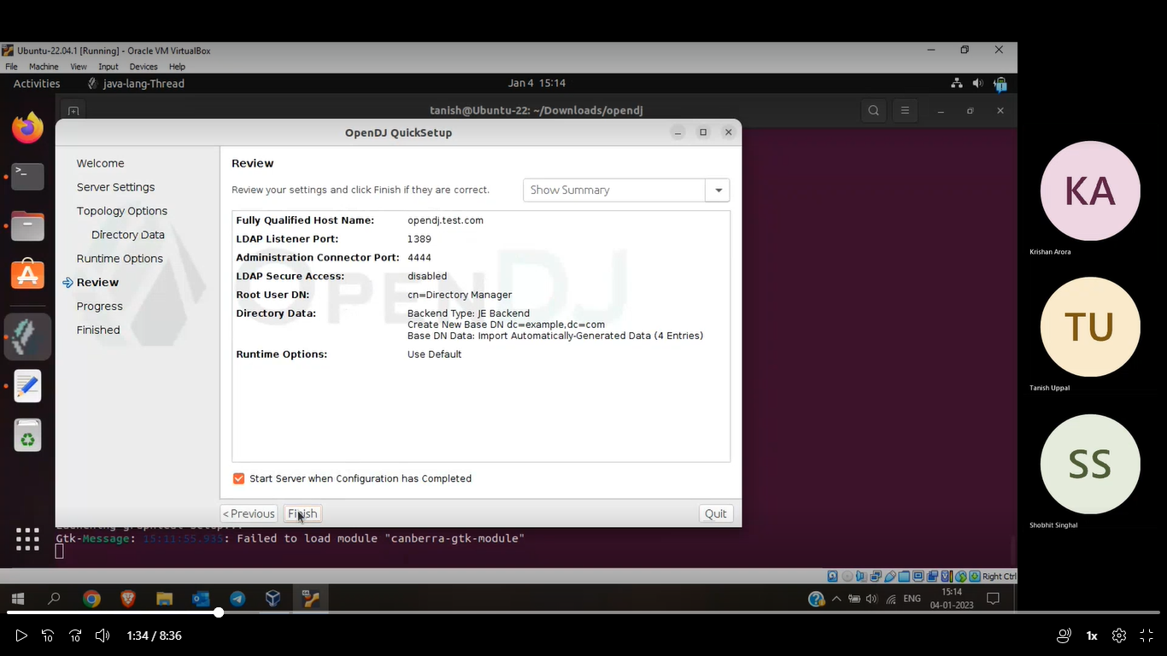

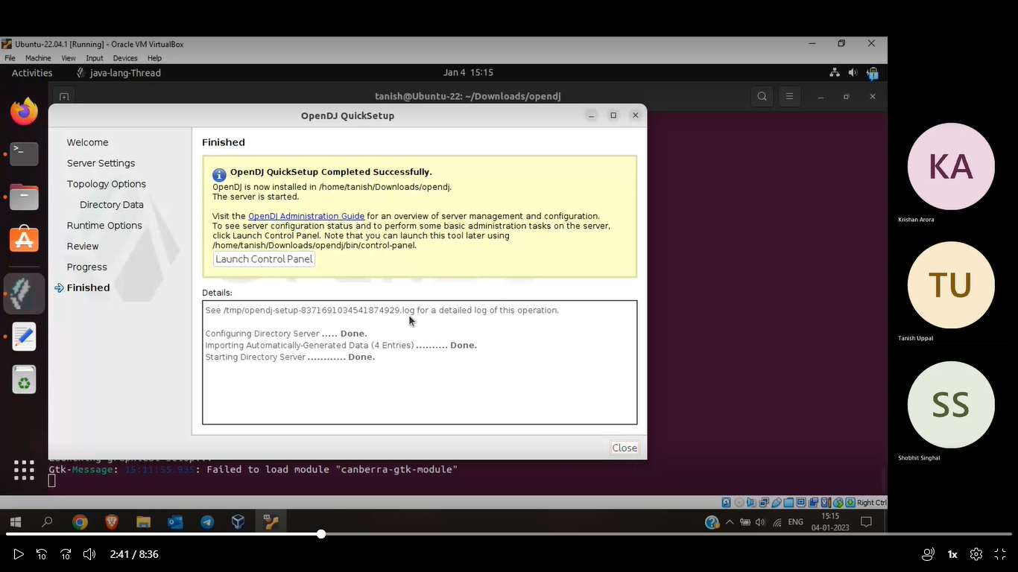

1. Now check if opendj is started or not by opening control panel :

cd /Downloads/opendj/bin 🡪 ./control-panel

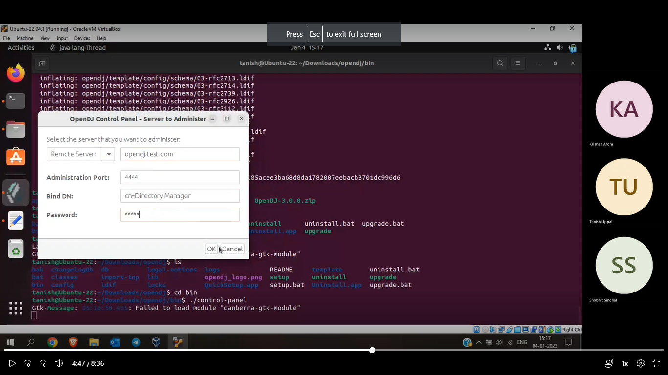

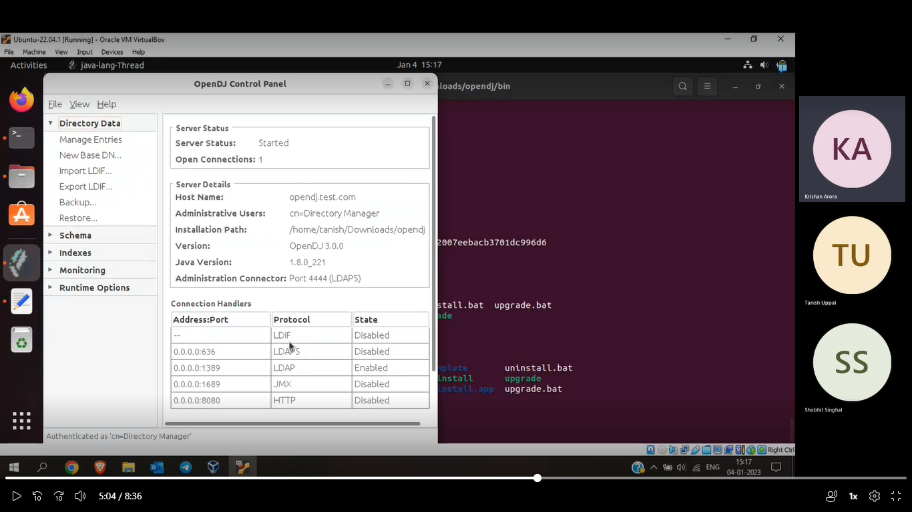

To start opendj: cd /Downloads/opendj/bin 🡪 ./start-ds

To stop opendj: cd /Downloads/opendj/bin 🡪 ./stop-ds

**Installation of Apache Tomcat Server (Version- 8.5):**

Video Link: <https://www.youtube.com/watch?v=Feui5F42bII&list=PLWUs-qjlPXmlx6gkb4bWQrIQizspT2Z7p&index=1>

1. Download tar.gz file in Core Section from <https://tomcat.apache.org/download-80.cgi#8.5.84>
2. Extract file: tar -xvzf apache-tomcat-8.5.84
3. Cd apache-tomcat-8.5.84/bin
4. Sh startup.sh

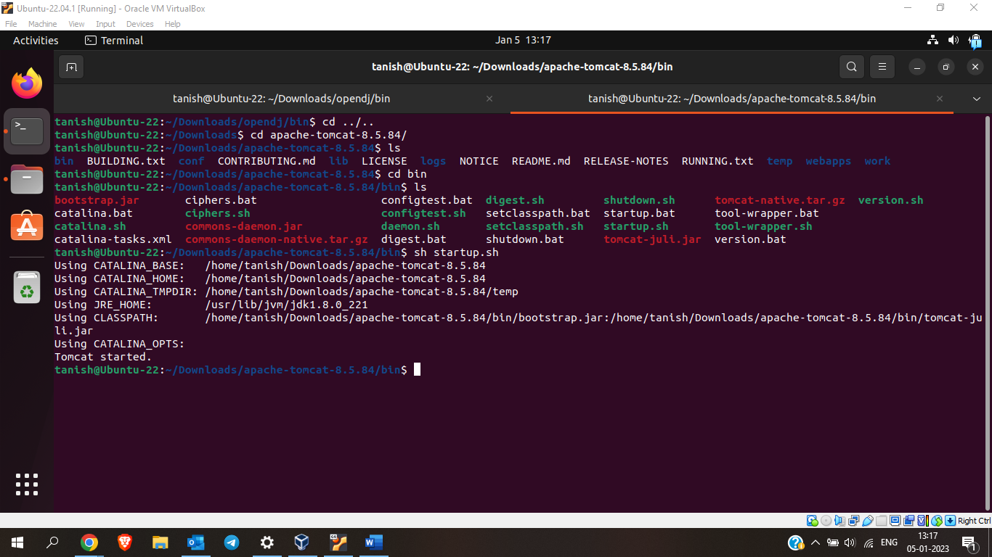

1. Now open firefox and check if tomcat has started or not on URL: localhost:8080

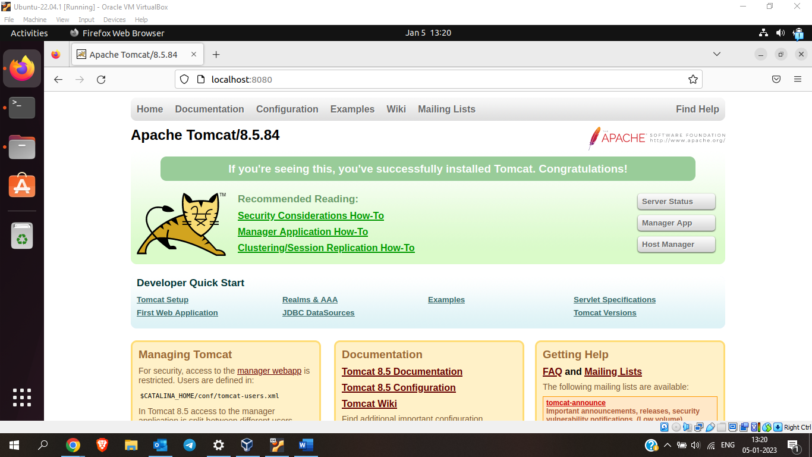

1. If you want to access manager app, You can do it by using default id and password or you can add a username and password by following below mentioned steps
2. cd apache-tomcat-8.5.84/conf
3. sudo nano tomcat-users.xml
4. Add following lines before </tomcat-users>:

<role rolename="manager-gui"/>

<user username="tanish" password="uppal" roles="manager-gui"/>

Give username and password as per your choice.

1. Save and exit
2. Now restart tomcat server and you will be able to access manager app.

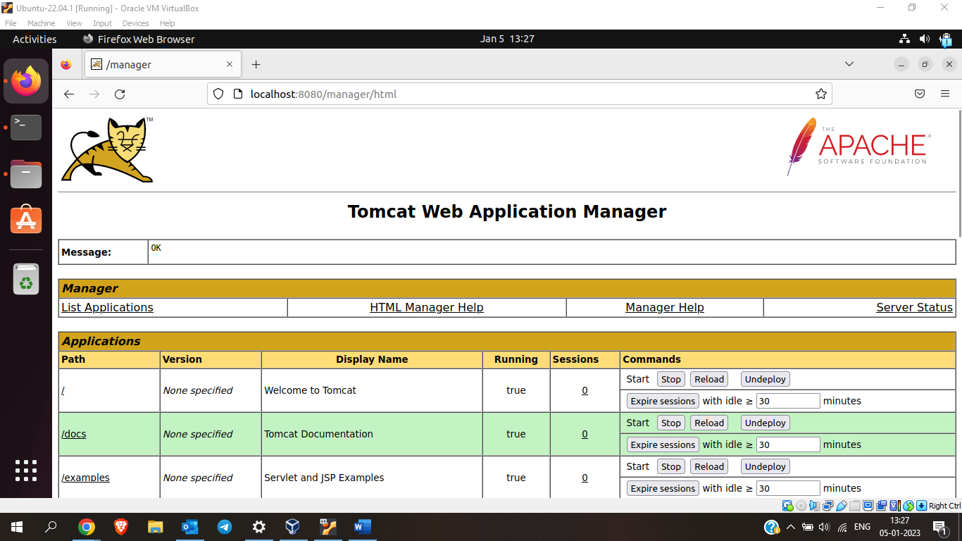

Start tomcat server: cd apache-tomcat-8.5.84/bin 🡪 sh startup.sh

Stop tomcat server: cd apache-tomcat-8.5.84/bin 🡪 sh shutdown.sh

**Installation and integration of OpenAM (Version- 6.5.1) with OpenDJ:**

1. Stop tomcat server
2. sudo nano /etc/hosts
3. Enter following line in opened file:

127.0.0.0 openam.test.com

1. Unzip Downloaded binary.
2. Copy AM-eval-6.5.1.war present in the unzipped folder into apache-tomcat-8.5.84/webapps
3. Rename it as per your choice(here renamed as openam) as this name will be used in thr URL afterwards.
4. Start tomcat Server
5. Now open firefox and enter URL: openam.test.com:8080/openam

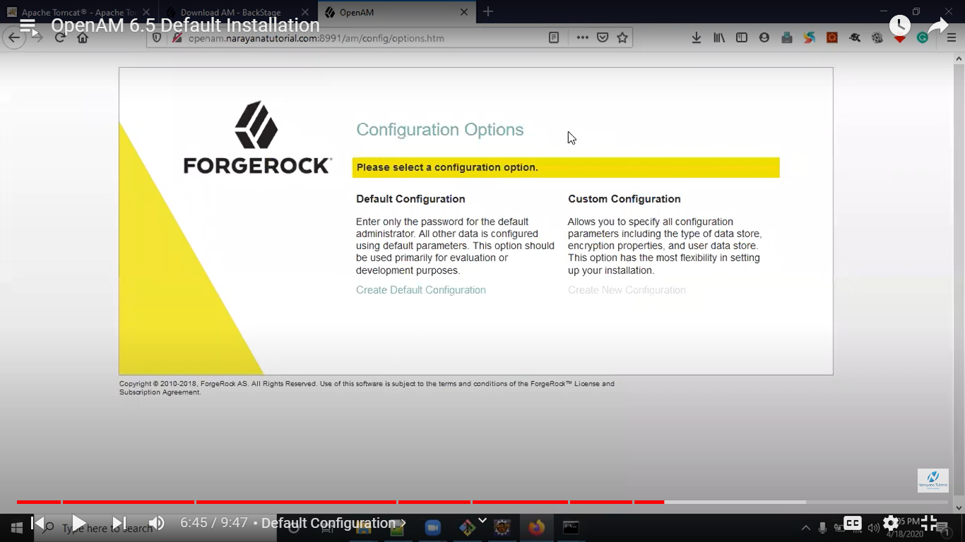

1. Now click on create new configuration under custom configuration and follow the screenshots below:

Give password as per your choice

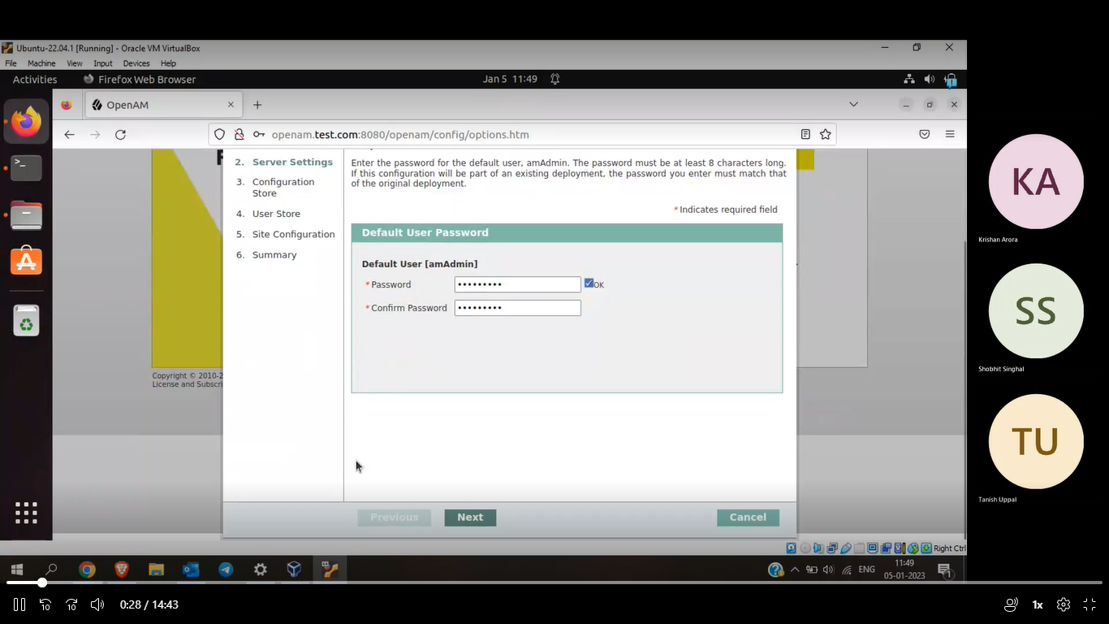

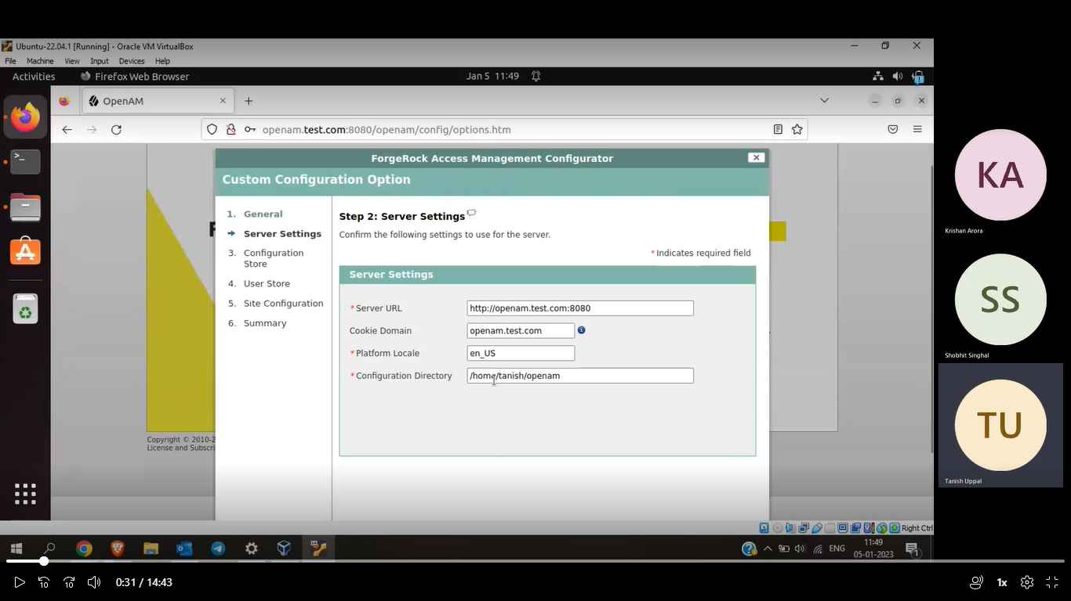

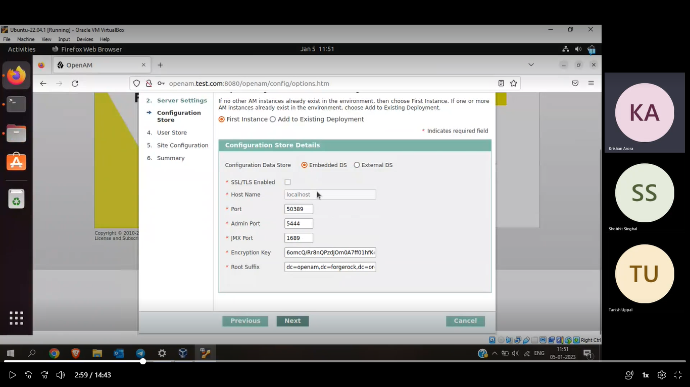

Enter details as per your OpenDJ configuration

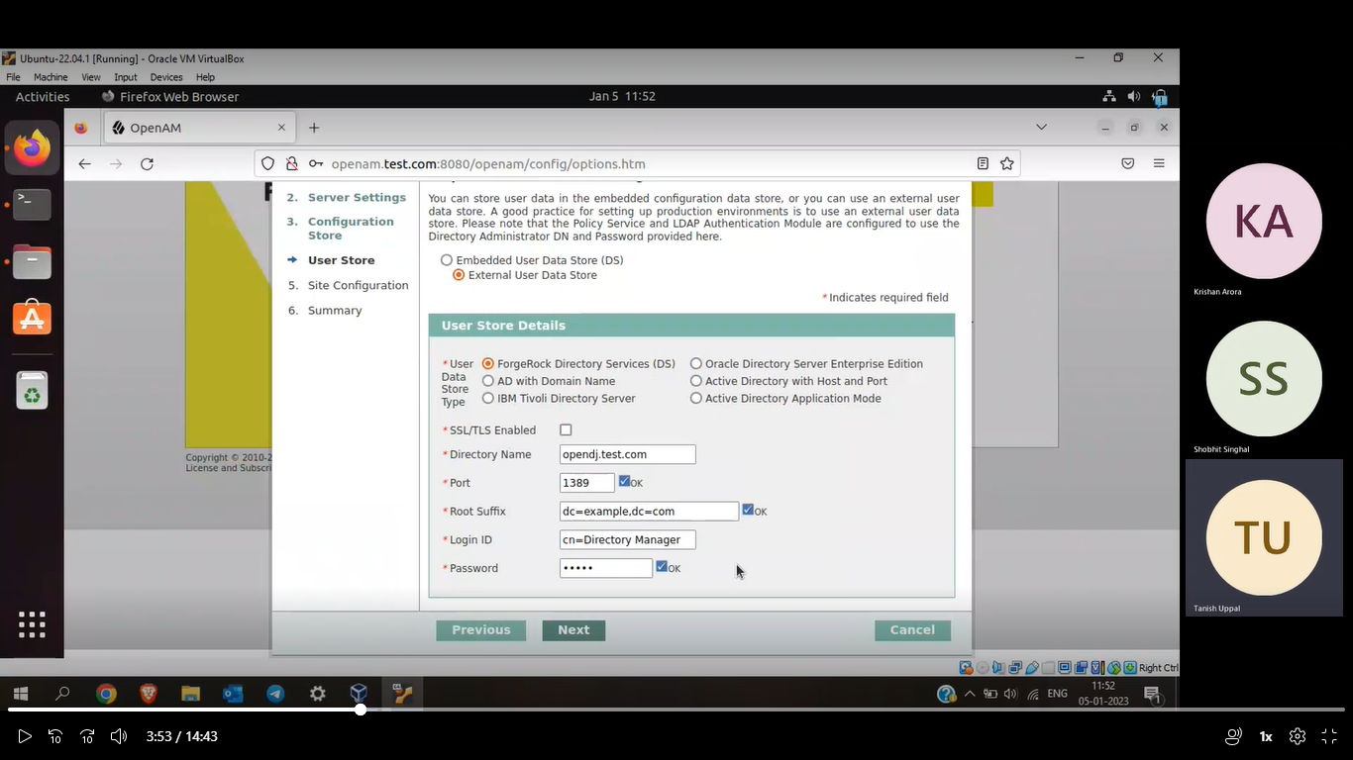

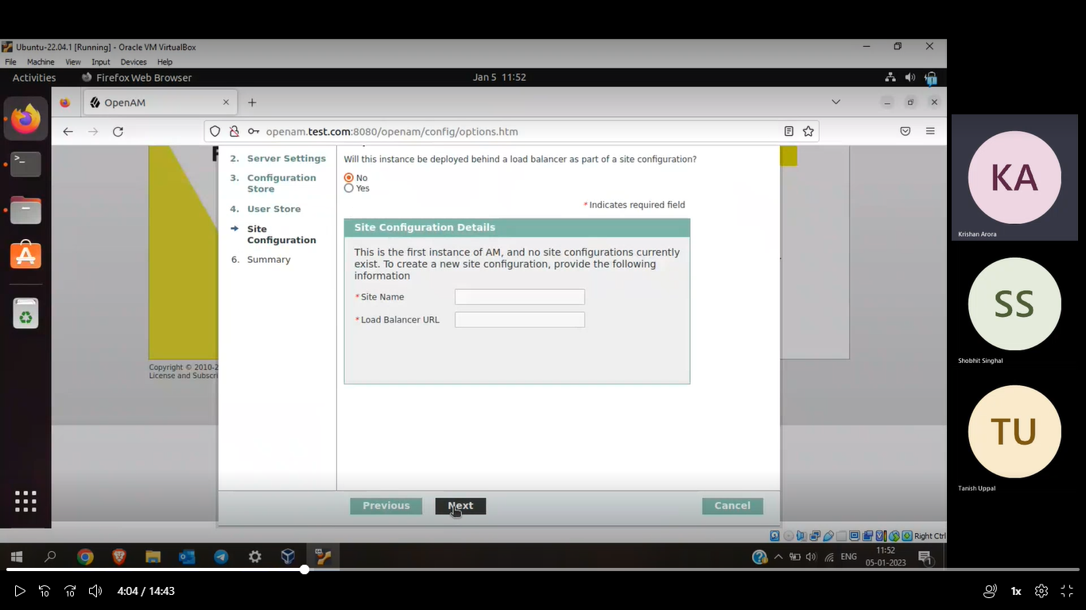

After checking your details, click on ‘Create Configuration’

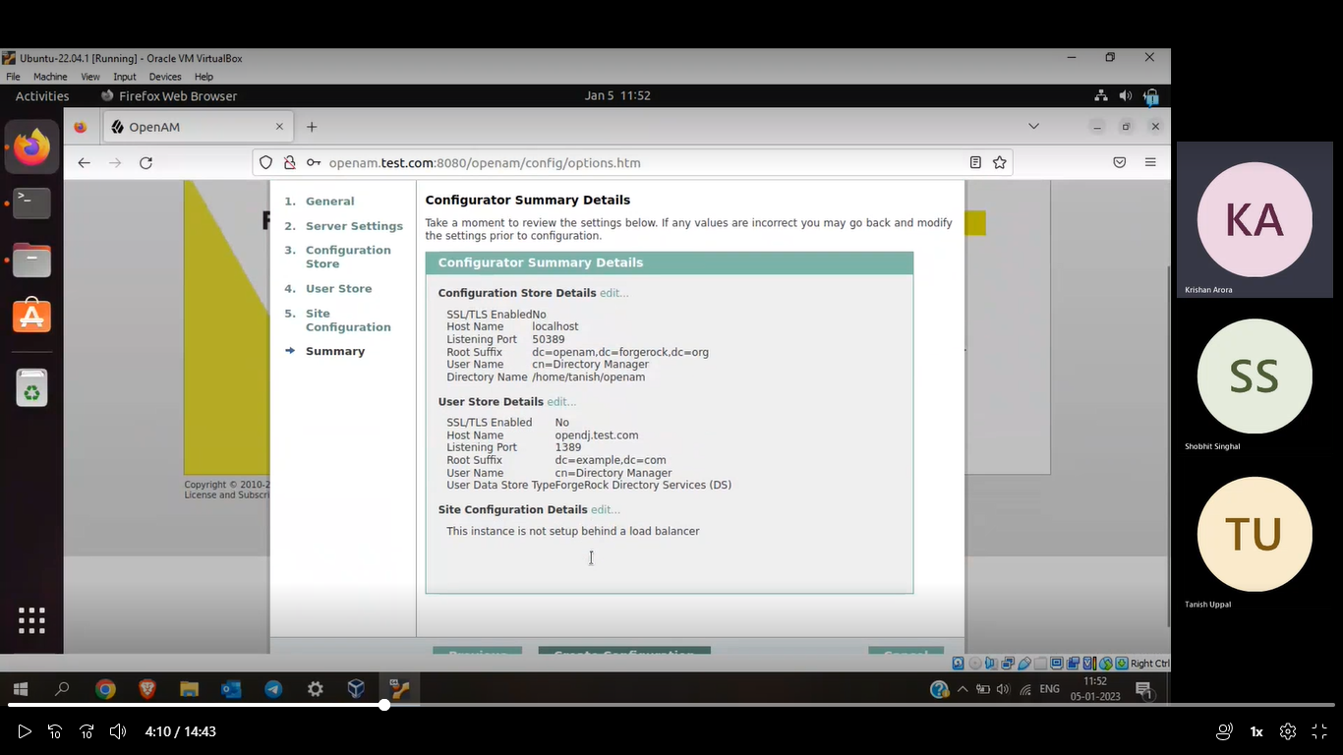

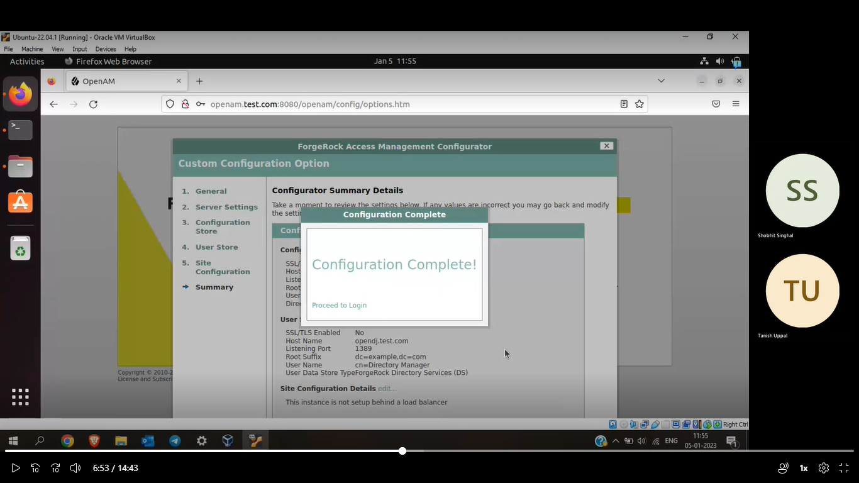

Now login into the OpenAm by using default username: amAdmin and password that you gave in the setup of OpenAm.

Click on the Realm and go into identities.

Your entries in Opendj should also be here.